Chapter 8.60
Food and Beverage Carts

Sections:

8.60.010 Definition
8.60.020 Permitted Uses
8.60.030 Standards and Review Processes
8.60.040 Standards for Food and Beverage Carts

8.60.010 – Definition. The definition of Food and Beverage Carts is as follows:

A. The sale of goods or merchandise from a location outside of a building in a mobile unit where at least 50 per cent of the sales is a combination of food and beverages. Examples include coffee carts and carts or trailers designed to serve food.

B. Exceptions include residential lemonade stands and similar short-term uses associated with residential uses.

C. Food and Beverage carts must be mobile units with wheels retained and licensed for road travel.

8.60.020 – Permitted Uses.

Table 8.60.020 identifies where Food and Beverage Carts are allowed. They are allowed in addition to the uses normally allowed in the underlying land-use district.

- P = Permitted Use.
- NP = Use Not Permitted

Table 8.60.020: Where Food and Beverage Carts are Permitted
Zoning | R-5 | R-10 | Commercial | Industrial | Public Lands and Facilities
Food and Beverage Carts | NP | NP | P | NP | P

8.60.030 – Standards and Review Processes

Table 8.60.030 designates time limits and review processes for Food and Beverage Carts. Applications shall be reviewed as specified in Chapter 15.07 of the Mosier Municipal Code as a Type I Decision.

Table 8.60.030 : Permit Duration, Renewals, and Review Processes
Permitting | Maximum permit duration | Are renewals permitted? | Review process
Food and Beverage Carts | 1 year | Yes | Type I, replacement cart on previously approved site

8.60.040 – Standards for Food and Beverage Carts

- Food and Beverage Carts shall be on a level surface such as but not limited to concrete, asphalt, pavers or other firm level surface where possible as approved by the City. Stable locations on level grass or gravel may be in consult with the City Engineer. If new paved surface is added to a site to accommodate a cart, location of the cart shall not cause the parking area to become non-compliant with applicable parking lot standards, including those in Chapter 15.03.130 of the Mosier Municipal Code (General Requirements for Parking Lots).

- Carts shall not occupy pedestrian walkways or required landscape areas.

- Carts shall not occupy parking needed to meet the minimum bicycle or automobile parking requirement for another use under Chapter 15.03.130. Blocking automobile access to parking spaces shall be considered occupying the spaces.

- If a site where a cart is located abuts a lot with a residential use, the cart use shall meet the existing setback requirements.

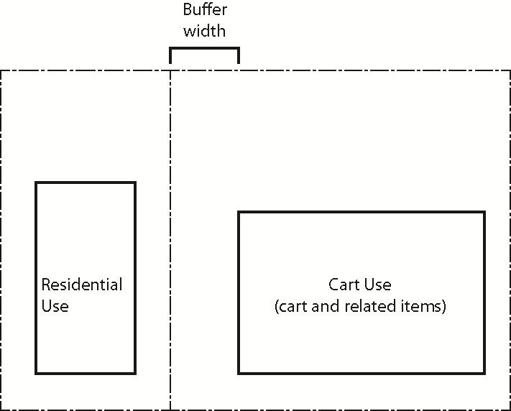
Setback Width
Figure 8.60.040 (D)

- The use shall provide adequate vision clearance as required by Chapter 15.03.130.

- Ingress and egress shall be safe and adequate when combined with the other uses of the property as required by Chapter 15.03.130.

- Uses shall not create tripping hazards in pedestrian or vehicular areas with items such as cords, cables and pipes.

- Awnings attached to Food and Beverage Carts shall have a minimum of 7 feet of clearance between the ground and the awning to allow access for pedestrians under the awning.

- Cart signage:
- Shall comply with applicable requirements of Chapter 8.20 (Sign Code).
- Signs are allowed on the cart, plus one sandwich board sign per use per street frontage, allowed only when the cart is operating.
- Wasco County Health Department food service licenses shall be posted in a location visible to customers.

- Unless otherwise specified in this section, Food and Beverage Carts shall be exempt from a finding of adequate public facilities unless it is determined that the proposed use exceeds the capacity of existing public facilities or causes unsafe conditions.

- The City may impose on any approval conditions intended to minimize adverse impacts created by the use on surrounding property and uses.

- Carts shall meet the following dimensional requirements:
- Minimum setbacks shall be met for the site perimeter.
- Carts shall not be located within 25 feet of an active driveway entrance as measured in all directions from where the driveway enters the site at the edge of the street right of way, as shown in Figure 8.60.040 (L).
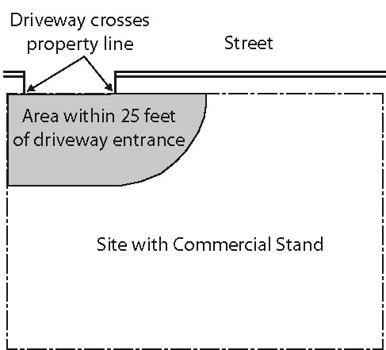
Site with Food and Beverage Cart
Figure 8.60.040(L)

- Carts shall be located at least 3 feet from the right of way or back of sidewalk; whichever provides the greater distance from the right of way.
- Carts shall provide at least 5 feet between service windows or other customer service points and an active drive aisle when located in a developed parking lot with clearly delineated parking spots and travel lanes. The distance shall be measured perpendicular to the service window/point as shown in Figure 8.60.040 (L)(4).
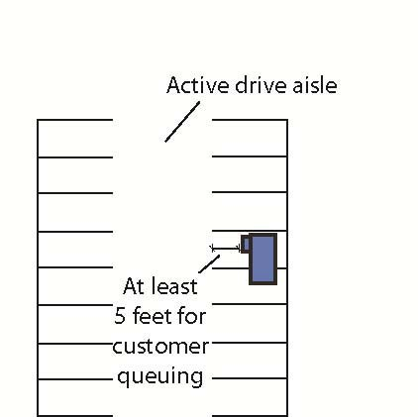
Figure 8.60.040(L)(4)

- Carts shall remain at least 10 feet away from other Food and Beverage Carts or Commercial Stands.

- Carts shall not occupy fire lanes or drive aisles necessary for vehicular circulation or fire/emergency vehicle access as determined by the City. Carts may occupy other drive aisles. In cases where a portion of a drive aisle is occupied, at least 4 feet of clear maneuvering space shall be provided between the closed portion of the drive aisle and the abutting active parking spaces, as shown in Figure 8.60.040 (M).

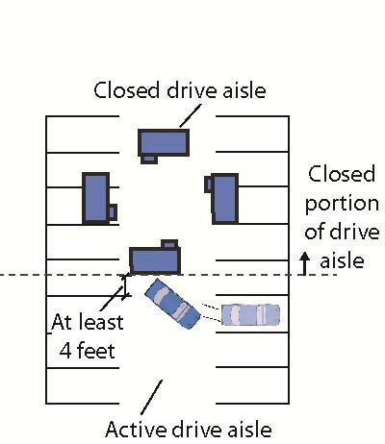
Figure 8.60.040(M): Space Between Active Parking and Closed Parking

- Carts shall utilize and fully maintain the minimum accessory items necessary for their operation and shall limit the visual effect of accessory items not used by customers. Such items include but are not limited to tanks, barrels and miscellaneous items. Measures to limit visual effect may include but not be limited to screening or storing them in containers to substantially limit views of such items from the street. Screening could be temporary fencing or landscaping (such as landscaping in pots or planters). Storage containers could be small sheds or storage units. Screening shall:

- Significantly limit views of items within 3 feet of the ground; and
- Allow views through the site between 3 and 10 feet to ensure surveillance of the site remains possible for crime prevention purposes.

- The following health and sanitation standards shall apply:

- Applicants shall provide wastewater/graywater disposal documentation that indicates how the outputs will be stored (if applicable) and what wastewater/graywater disposal method will be used. The documentation shall indicate a proper disposal method that ensures fats, oils and grease do not enter the City’s wastewater infrastructure. Non-stormwater discharges to the City’s stormwater system are prohibited.
- If the applicant intends to contract with a third party for wastewater/graywater disposal, a copy of the contract must be provided to the City within 30 days of receiving a permit.
- The City may require the food or beverage service operator to provide proof of payment or other documentation that wastewater and graywater are being disposed of properly.

- For sites with more than one Food and Beverage Cart, at least one-third of the carts within 25 feet of each street right of way shall have a primary service window facing the street. If the cart is within 25 feet of more than one street, it shall face its primary service window to the primary street. The primary street shall be the street with the highest classification or as determined by the Manager. If the service window faces a landscape area between the cart and the sidewalk and no sidewalk entrance is located within 30 feet of the service window, a paved pedestrian path is required between the cart and the sidewalk. A grouping of carts can share one path.

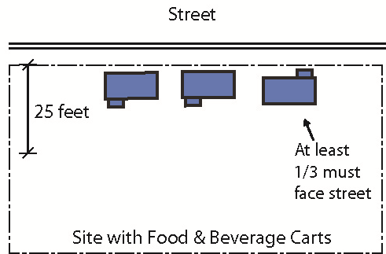
Figure 8.60.040(O)

- The applicant shall provide an estimate of the parking demand on the site and provide information about how parking demand will be accommodated, such as through off-street parking or on-street parking on adjacent blocks. That analysis shall consider parking needs of other uses on the site. Off-street parking may be required by the Manager if the applicant cannot demonstrate adequate parking is available to meet demand or it has been determined that a renewing Food and Beverage Cart has experienced parking or related traffic issues on the site or on adjacent blocks.

- Carts shall have lighting to ensure a safe environment for customers. If permanent lighting, such as parking lot lighting, already exists on the site, the City may determine that the lighting satisfies this requirement. Otherwise, lighting (such as temporary lighting) shall be added that complies with Chapter 8.30 of the Mosier Municipal Code (Outdoor Lighting) and with the following:

- At a minimum, areas intended to be occupied by customers, such as areas near Food and Beverage Cart service windows and customer seating, shall be illuminated when carts are in operation during hours of darkness; and
- No direct light source shall be visible at the property line adjacent to residential at 3 feet above ground level; and
- Lighting fixtures shall be oriented and/or shielded so as not to create glare on abutting properties; and
- The City may modify lighting standards if such modifications are deemed necessary and appropriate for the use and surrounding area and help meet the intent of the standard.

- Carts and their accessory items visible from the street shall be kept in good repair and be maintained in a safe and clean condition in compliance with the following:

- Carts shall not have missing siding, skirting, or roofing.
- Carts shall not have more than 10% of any side experiencing rust, peeling paint, corrosion, or other deterioration.
- Carts shall not have components or attachments in disrepair in a manner that causes an unsafe condition.
- Tents and canopies associated with the carts shall not have:
- Tears in the tent/canopy material that exceeds 6 inches.
- Mold on more than 10% of the material.
- A lack of anchoring.

- Broken or non-functioning supports.

- Food and Beverage Carts shall not have any internal floor space available to customers.

