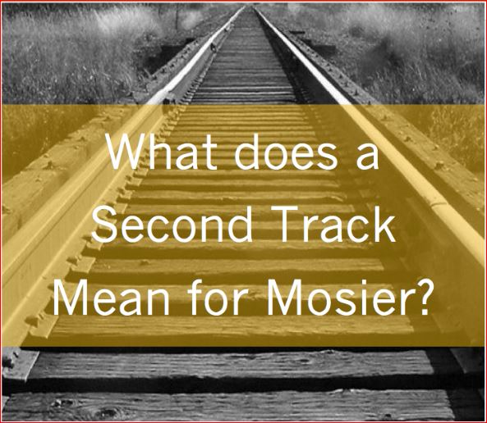

AGENDA: CITY COUNCIL MEETING
September 7th, 2016 at 6:30 P.M.
Mosier Senior Center at 500 East Second Ave.
I | 6:30pm | Call to Order (please silence or turn-off cell phones)
II |  | Agenda corrections or additions
III |  | Business from the Audience-- This is an opportunity for Mosier residents and anyone else to express concerns, needs, or opportunities. Please keep your comments succinct and under two minutes. You may bring in written materials for Council and Staff to review. The Mayor can assign the issue to a future Council meeting, to a Council Committee, or to staff. Please realize that council cannot offer any response immediately, but will give the matter due consideration. | 10 minutes
IV |  | Approval of City Council Meeting Minutes: 8/17/2016
V |  | BUSINESS
1. | 6:45 pm | Mosier’s Urban Forest Management Plan: Christine Johnson and Katie Lompa  from the Oregon Dept. of Forestry | 30 min
2. | 7:15 pm | UPRR: Mosier Double Track (Main Line) project presentation | 45 min
3. | 8:00 pm | Application for Council Vacancy: Acasia Berry | 5 min
4. | 8:05 pm | Construction Activity Restrictions: UPRR Double Track application | 5 min
5. | 8:15 pm | Mosier Creek Bridge Preservation Project and Mosier water/sewer line project | 10 min
VI | 8:25 pm | Correspondence/Staff/Council reports  Committee Reports | 10 min
VII | 8:35 pm | Adjourn

