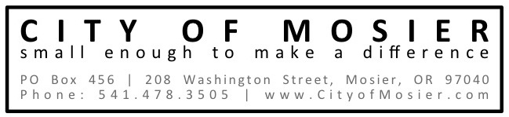
2014 Rate Schedules: Water, Sewer, SDCs (Connection Charges)
Monthly Service Charges: Single Family Residential
Water | $33.21
Sewer | $63.00

Monthly Sewer Charges: All Users
Single Family Residential | $63.00
Multi-Family Residential (per unit) | $63.00
Schools | $315.00
Commercial (including B&B) | $94.50
Accessory Dwelling Unit | $47.25
Non Profits (< 10,000 gallons water use) | $47.25

Water Consumption Rate: All Users
0-6,000 gallons | $1.50 per 1,000 gallons
6,000 – 14,000 | $2.00 per 1,000 gallons
14,000 + | $2.50 per 1000 gallons

Monthly Water Service Charges (All Connection Types)
Meter Size | Monthly Service Charge
¾ inch (Residential) | $33.21
1-inch | $83.03
1 ½-inch | $166.05
2-inch | $264.68
3-inch | $531.36
4-inch | $830.25
6-inch | $1,660.50
8-inch | $2,656.80

System and Development Charges for ¾” Residential
Parks | $1,495.00
Water | $4,499.00
Sewer | $5,718.00
Stormwater | $ 931.00
TOTAL Residential SDCs: | $12,643.00

Mosier Bluffs additional SDC charge for Water | $4,032.00
TOTAL SDCs for Mosier Bluffs: | $16,675.00

