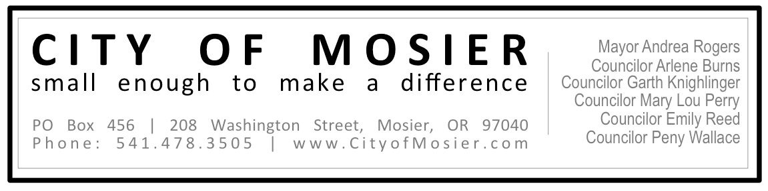

Information About the Proposed Sewage Rate Increase

Since the Budget process of May 2013, the Mosier City Council has been discussing the need to increase sewer utility rates in order to cover the cost of operations, maintenance, and the loan payment for the publicly-owned Waste Water Treatment Plant. The City Engineer conducted a rate study this spring and presented the information to Council during a series of public meetings in May and June 2014.

Council will deliberate on a resolution to increase sewer rates on July 16th at 7 pm at the Mosier Senior Center during the regular City Council meeting. Please attend this meeting if you have questions, concerns, or comments.

History – How we got here

In 2008, the State required the City to modernize the Waste Water Treatment plant because the plant was old, unreliable, and could not meet clean water regulations. This cost the City $2.2 Million and raised the monthly rates from $40 to $59 per household.

During the building phase, oil contamination from an unknown source was found on the site and the clean-up increased the overall cost of the new WWTP. However, the council at the time voted to wait on increasing sewer rates and to monitor the need.

One expectation was that the costs would be offset by new property developments (connection charge revenue) but the recession stopped these new houses from being built.

The rate has stayed at $59 for the past 6 years.

At the same time, our sewage operation service, OMI, increases their rates by an average of 3% (or approximately $1500 per year). Note: this is higher than the Consumer Price Index.

The result is that the City has been operating in the red, covering the gap between income and costs by spending approximately $25K from the reserves each year. That reserve is now completely gone and we have just enough to make our loan payment next year.

We cannot run a deficit without defaulting on the loan. At that point the State will garnish all City accounts and will demand payment.

Note: we are unable to move money from any other fund to cover the sewer fund.

What this means:

We are considering a $4/month increase in the sewage rates (from the current $59 to $63 per household). The City would also implement a yearly rate increase based on municipal price index.

What are we are doing to address this issue?

Staff Costs
During the past few years we have moved our staff costs (time spent on sewer billing and maintenance) from the Sewer fund to other funds within the overall budget. This is a short-term solution that allows us to save costs in the area until we have a permanent solution.

Replace OMI
Many of OMI’s customers are frustrated with their rate increases. We have been working with MCEDD to contact 6 other city sewer customers in the Gorge to explore the possibility of forming a network to create & share a replacement service. We will need at least 3 of these towns to sign on to make this a cost effective option. Costs include a laboratory, certified operators (main operator + backup) and the transportation of sludge to Hood River (biggest cost).

Identifying Unapproved ADUs
The City is currently investigating the number of houses with accessory dwellings who are currently not paying for sewage use. Owners will be contacted.

Development
The City is also actively looking for ways to bring in more homes and businesses to help share the costs of our sewer and water systems. These efforts include cooperative completion of the water system for the new housing development, downtown beautification to help attract visitors, interest, and investment in the community, and streamlined new business ordinances (eg signage & food carts) to make it easier for businesses to get started.

Related Notes:

- 65% of the current rate is used just for debt service.
- The City is not allowed to use connection charges on operations and expenses.
- Our reserve still includes $55K, which is mandated by the State and cannot be touched in any way – to be used only in the case of default.
- OMI will not provide us with a line item budget break down.
- Other city sewer rates: Lyle $60, Klickitat $65, Portland $70.
- The good news is that we have a state-of-the-art water & sewage system and a healthy City budget. Many towns are unprepared for the inevitable upgrades & repairs that are necessary to maintain their systems.

Please attend the City Council meeting at 7 pm on Wednesday, July 16th at the Mosier Senior Center at 501 E. 2nd Ave. if you have questions or concerns!

