PO Box 456 / 208 Washington St. Mosier, OR 97040
Phone: 541-478-3505 Fax: 541-478-3810
mosiercityhall@mosierwinet.com

Food and Beverage Cart Permit Application

Contact Information for Person or Entity Responsible for Proposed Food/Beverage Cart
Name
Street Address
City ST ZIP Code
Home Phone
Work Phone
E-Mail Address

Detailed Description of the Food Cart

- Total length of trailer and/or cab:

- Does the cart have the required license for road travel? (Please include a copy with this application)

- Is the cart a stand-alone trailer or is it an integral part of a vehicle?

- Is the cart and its accessory items in good repair as required (requirements listed below)? (Please include a photo of all sides of the cart.)

Requirements:
- Carts shall not have missing siding, skirting, or roofing.
- Carts shall not have more than 10% of any side experiencing rust, peeling paint, corrosion, or other deterioration.
- Carts shall not have components or attachments in disrepair in a manner that causes an unsafe condition.
- Tents and canopies associated with the carts shall not have:
- Tears in the tent/canopy material that exceeds 6 inches.
- Mold on more than 10% of the material.
- A lack of anchoring.

Parking

5. Please provide an estimate of customer parking needs and describe how this will be accommodated.

Health and Sanitation Standards

- How will wastewater/graywater be lawfully disposed of?

- How will garbage/solid waste be collected and lawfully disposed of?

Signage

- Signage is allowed on the cart. Will you use the one sandwich board sign per use per street
frontage that is allowed only while the cart is operating? If other signage is to be used, describe how it complies with Chapter 8.20 (Sign Code.)

- Where is the North Central Public Health District license posted and is it in a location visible to customers?

Time Schedule of Use

Describe the dates, times and frequency that the cart will be open for business.

Site Plan

Please provide a site plan drawn to appropriate scale include sufficient surrounding area to show how the cart location complies with the following requirements:
- Does the proposed Cart location avoid occupying:
- Pedestrian walkways
- Parking areas needed to meet minimum parking standards?
- Fire lane or drive aisle necessary for vehicle circulation?
- Existing setback requirements?

- Is the cart located within 25 feet of an active driveway entrance as required?
- 3 feet from the right of way or back of sidewalk.
- 5 feet between service window and an active drive aisle.
- 10 feet from other Carts or Commercial Stands

- Show how much are is needed for the use and for all supporting uses.

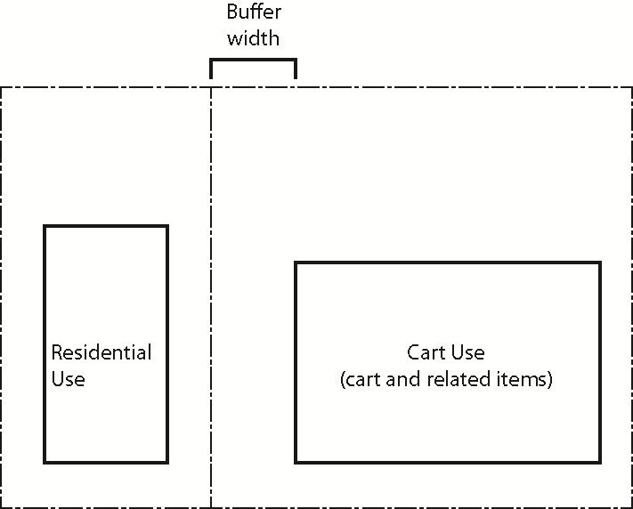
Sample Siting Requirements:

- Setback Widths Required from Residential Zones = 5 feet
5 feet
5

5Five

- Sight Clearance and Sidewalk Clearances
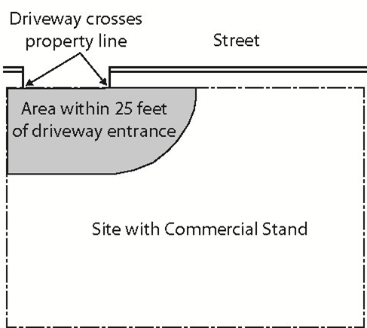

- Provide for Active Drive Aisles and Customer Queuing
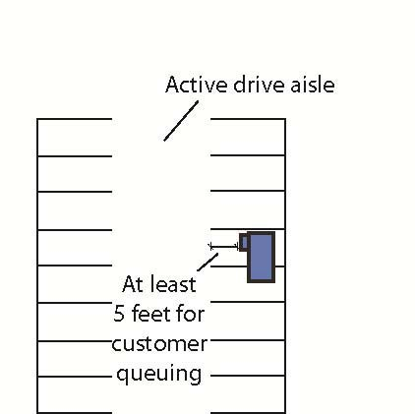

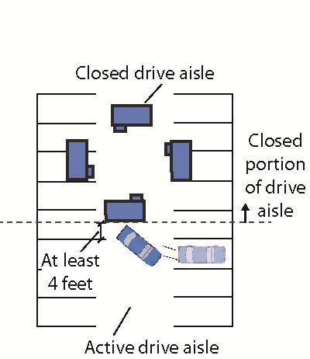

- Maintain Relationship to City Streets:

